Trader Web Interface

**Traders (PHP)**

Login

First traders need to Log in order to sell the product.

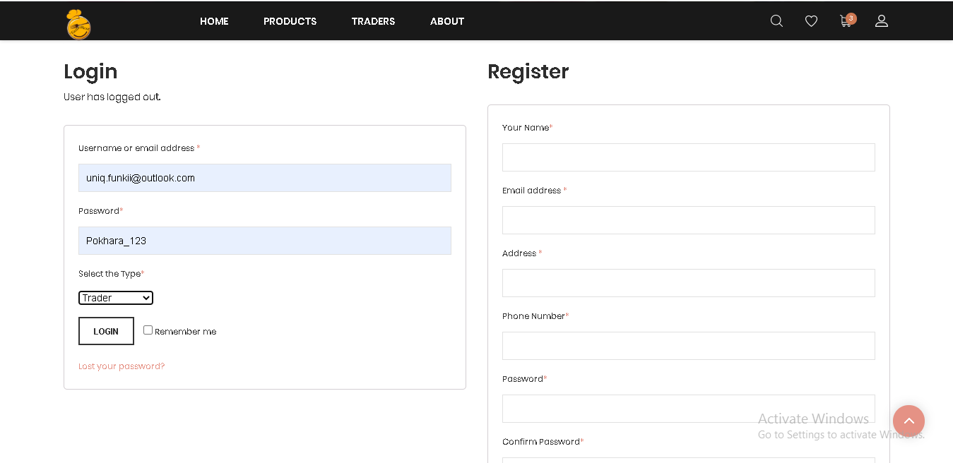

Customer will receive OTP in email after email verification and then applying valid OTP code person will be verified as a customer.

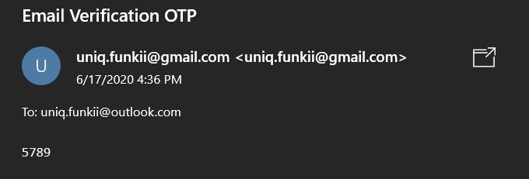

OTP and password sent in customer account. After pasting the valid password in required filled customer can log in again.

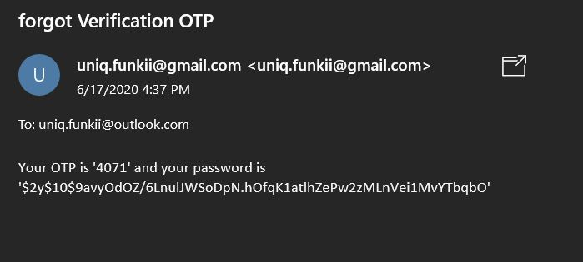

# 

# 

# Trader Products Dashboard

We have 5 products dashboard, this one is the butcher dashboard. Similarly we have same other dashboard .From the trader product dashboard we can insert,view,edit and delete our products easily and edit the butcher account too. In trader dashboard We can also display 10 products and also have the product categories . We can easily view the details of that products . We can also view our website from this dashboard.

Click on butcher name on the top right side of the trader dashboard and then click on logout. We are successfully logged out.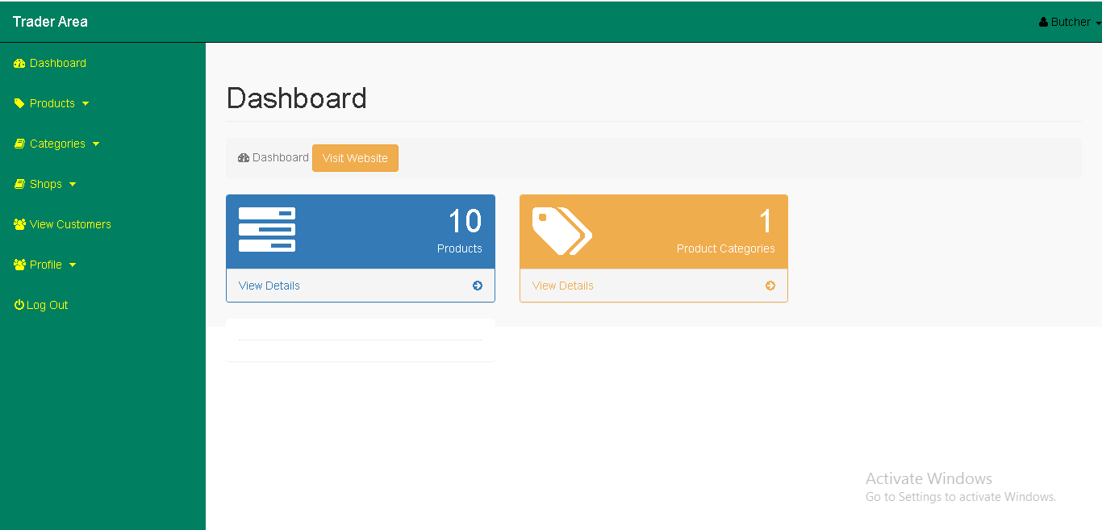

# 

# Insert products

Click on product drop down and click on insert product an insert product form will appear fill the details and click on insert product.

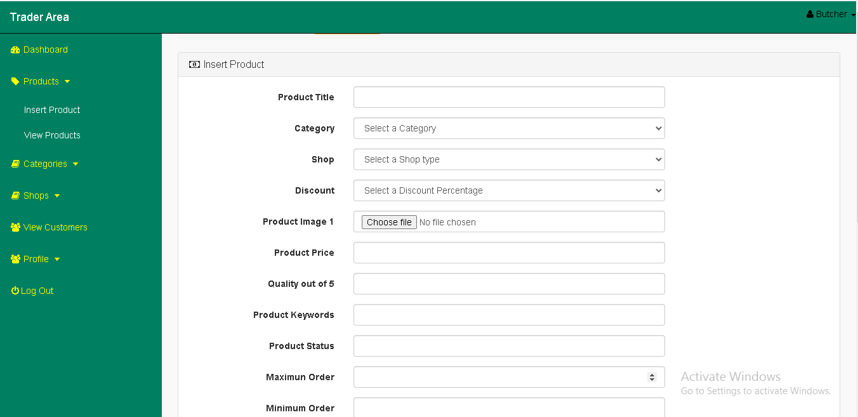

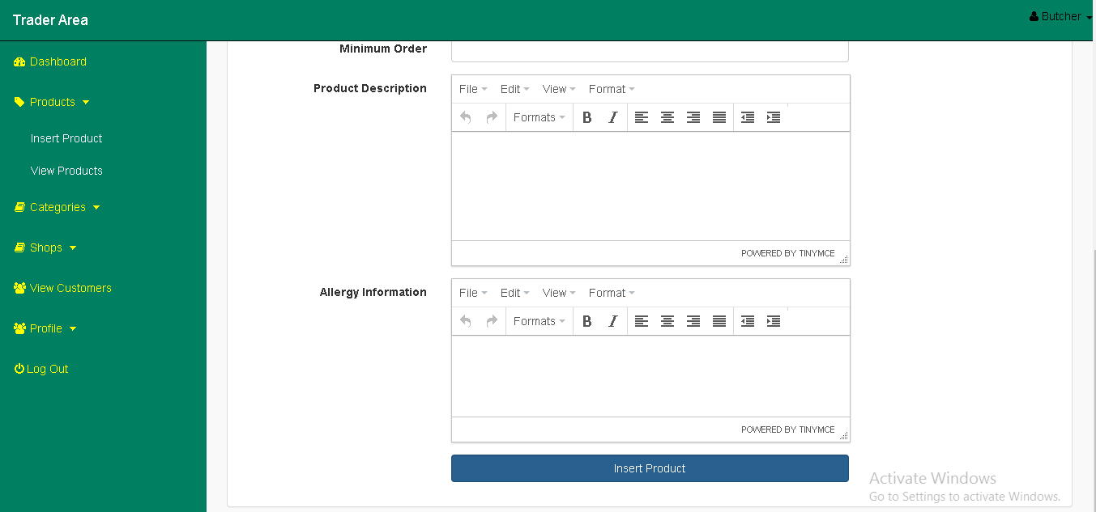

# View products

Click on product drop down click on view products here you can see the inserted products.

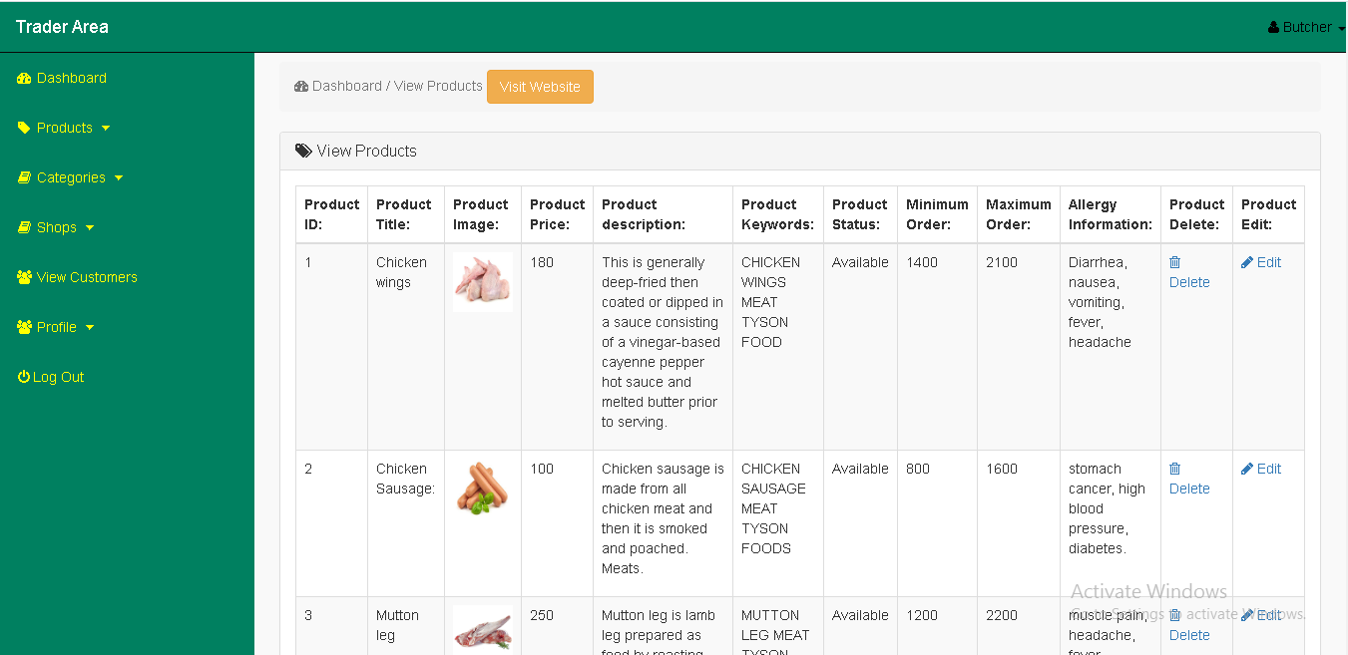

Edit Products

On the view products page you will see an edit button on the right hand side of the page click on edit an edit form will change the details and click on update product.

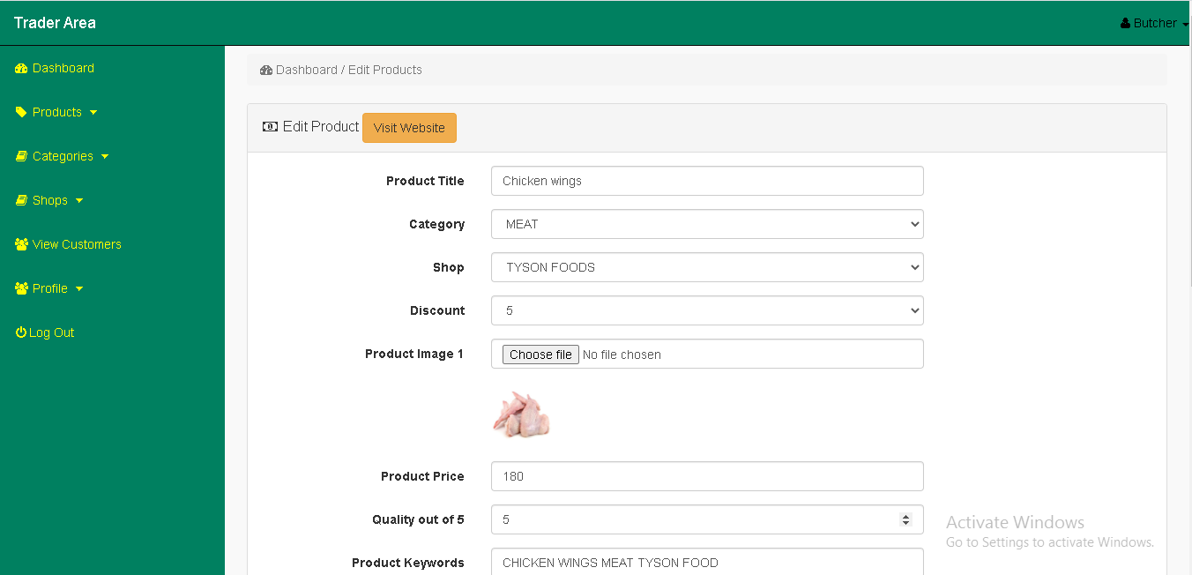

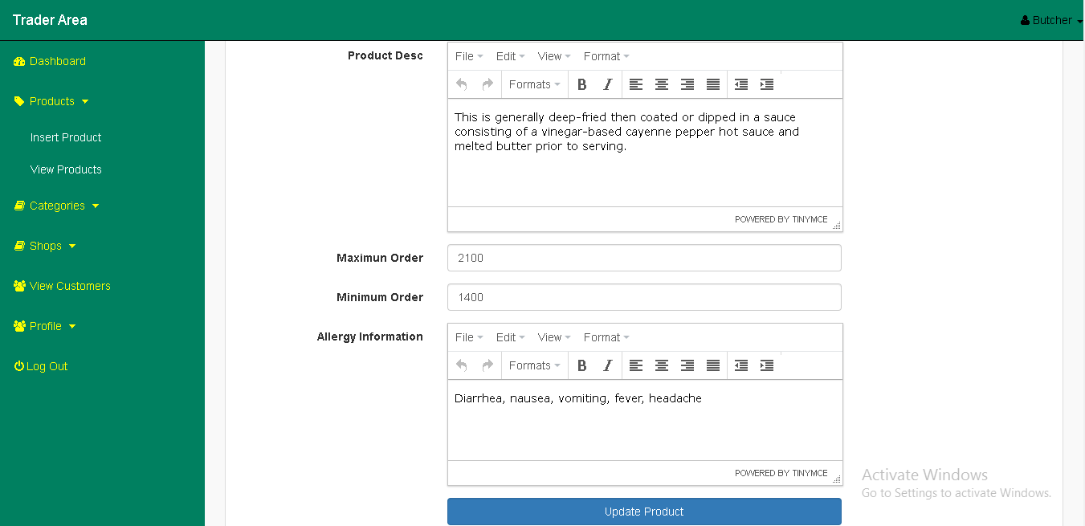

# Delete products

On the view products page you will see a delete button on the right hand side of the site. When you click on it, it will delete your product.



View Product Category

At the left hand side of the site you can see categories page when you click on it we can easily view our product category ID, Category Name and Product Quality.

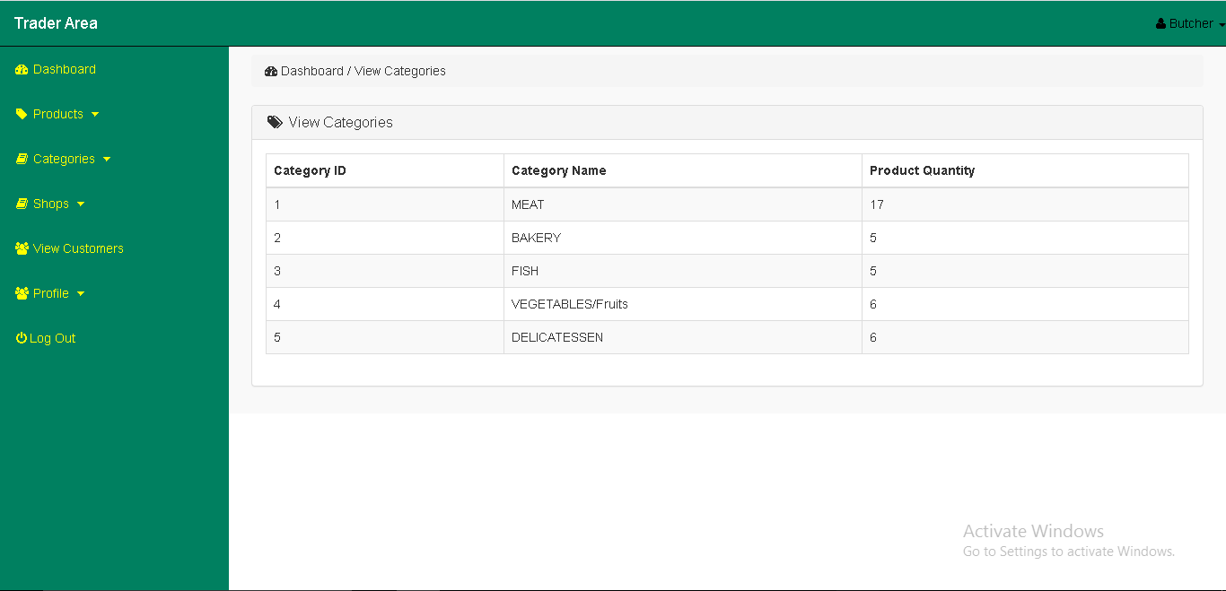

Insert Shop

On the shop page you will see insert shop on the right hand side of the page click on insert shop you can easily insert shop name and description

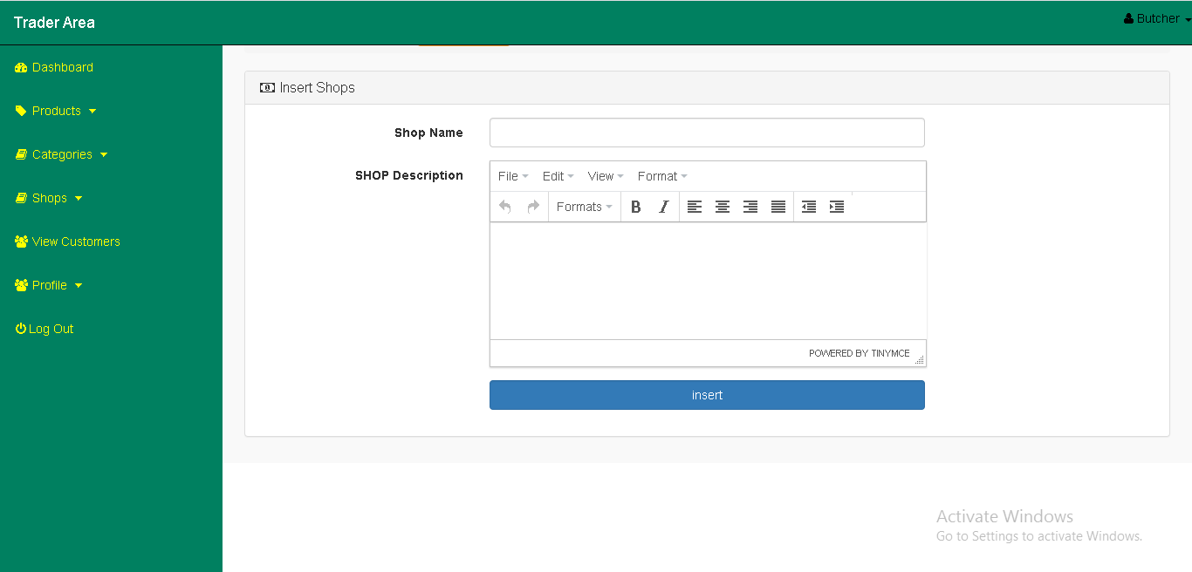

aaaaaaaaaaaaaaaaaaaaaaaaa

View Shop

On the shop page you will see view shop on the right hand side of the page click on view shop you can see all shop ID, Name and Description. You can also edit and delete your shop ID, Name and Description.

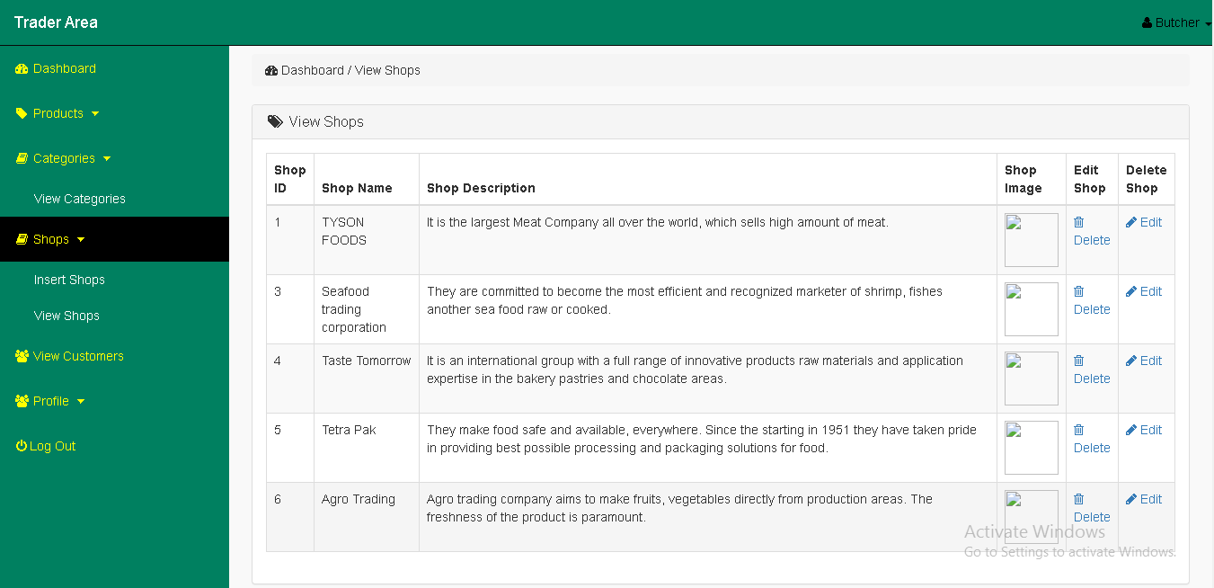

Update Shop

We can easily edit your shop name and shop description as your wish.

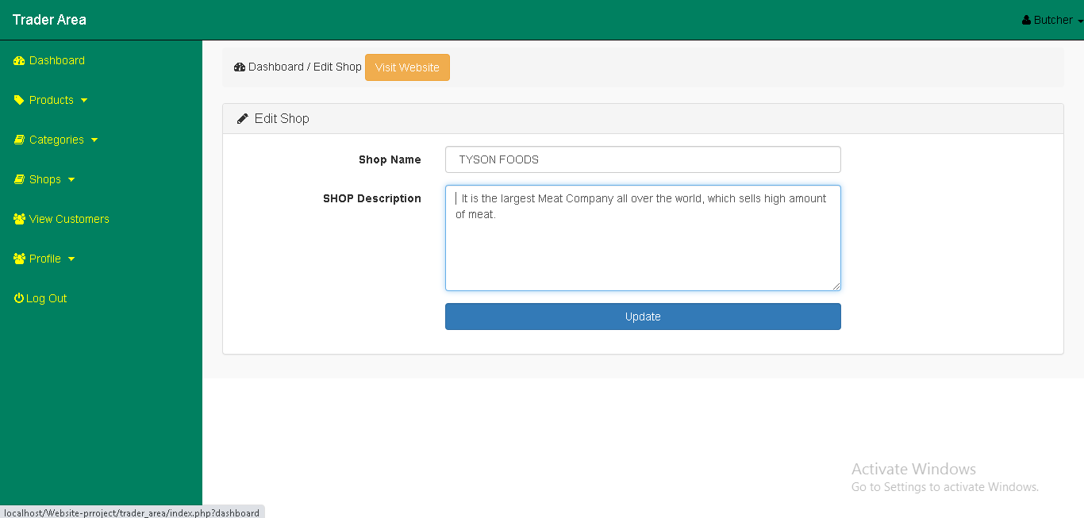

View Profile

On the profile page on the right hand side of the site you will see view profile and edit profile. When you click on view profile we can see the information about the user.

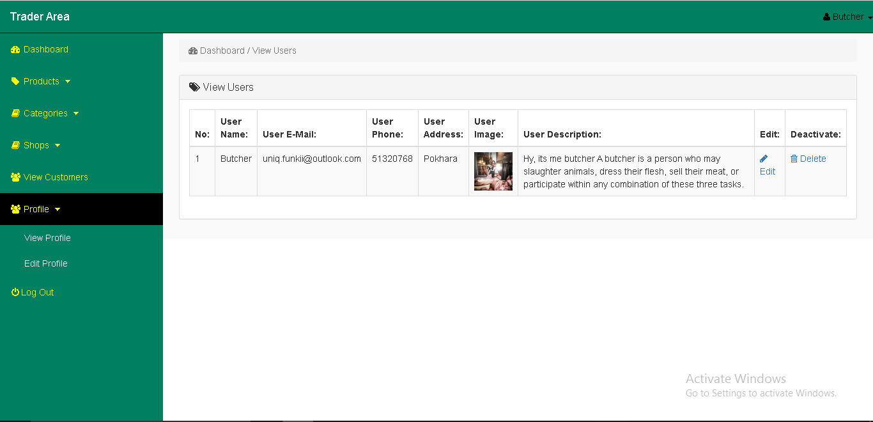

Edit Profile

On the profile page on the right hand side of the site you will see view profile and edit profile. When you click on edit profile we can edit all the information of user.

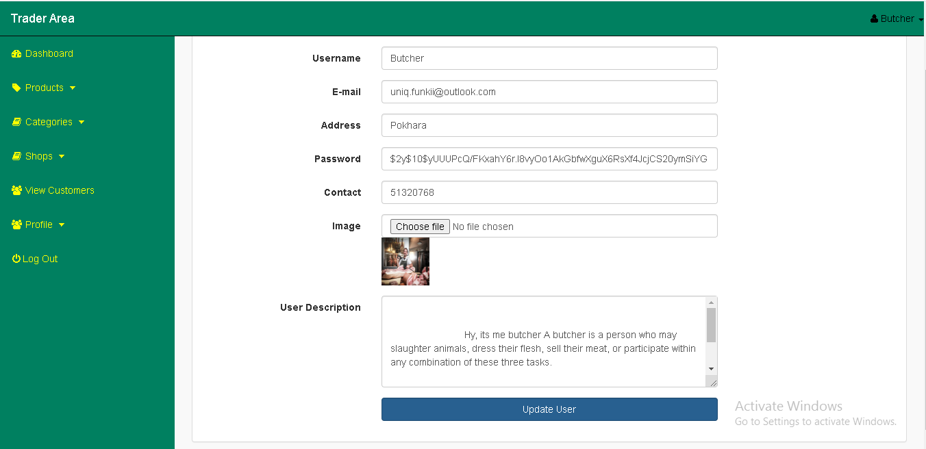

Deactivate Account

If we click on deactivate account, trader dashboard goes at the login page so when we login with our email and password then you can see the otp page, when we write activate in that OTP page then it immediately activate.

